One Dimensional Motion

Name: Firehiwot Senbetu

Download and install the “Moving Man” simulation from:
https://phet.colorado.edu/en/simulation/legacy/moving-man
Familiarize yourself with the simulation. Play around with the settings, change the position, velocity and acceleration, record the motion, and playback in slow motion. When you are finished testing all the settings, click on the “Reset All” button.
Step 1: Set the velocity 0.5 m/s by typing 0.5 in the velocity box. Click on the play button, the man will start moving towards the house. Pause the motion between the 8 and 10 meter marks, before the man hits the wall.
Step 2: Click on “Playback” button. Then click on the “Play” button to play back your measurement that you recorded in Step 1, notice that a vertical bar scans through the graphs and the corresponding position, velocity and acceleration values are displayed for each time of the man’s motion, time is displayed on the horizontal axis of the graph. 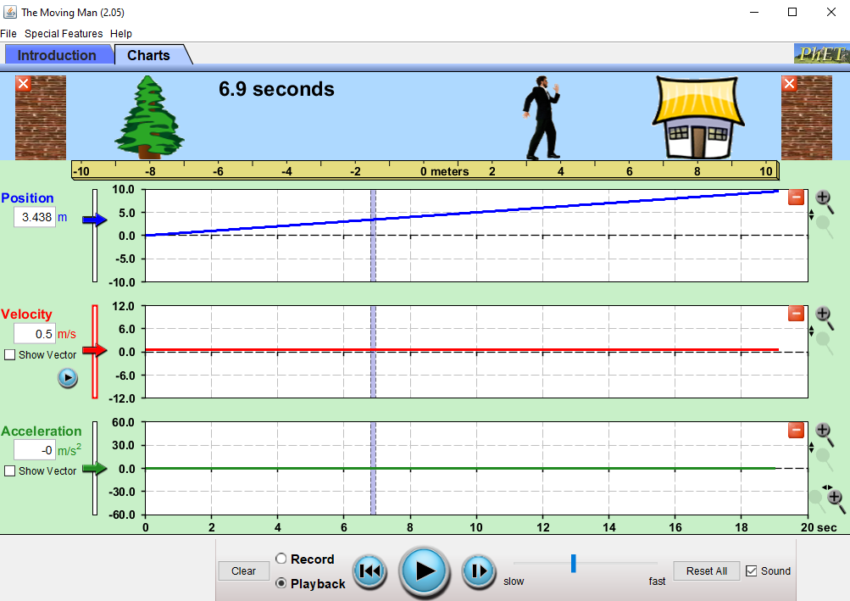
Step 3: Click the “Rewind” button and then “Play” to playback again, and “Pause” after a few seconds. Now use the mouse to drag the vertical scanning bar to time 8 s (the center of the bar should be exactly at 8 s mark on the horizontal axis of the graph). What is the position displayed in the “Position” box?
Position (at time = 8 s) =4m
Did you expect this to be the position of the man at time = 8 s (based on your initial settings of the simulation), explain your reasoning?
Your answer:

Step 4: Click “Play” and keep an eye on the velocity and acceleration boxes.
How does the velocity change as the time and position change?
Your answer: Velocity remain constant
How does the acceleration change as the time and position change?
Your answer: Acceleration remain constant
Step 5: Click the “Reset All” button. Type “-10” in the position box, “0.1” in the velocity box, and “0.2”in the acceleration box. Click “Play” and observe the three graphs carefully. Pause the motion between the 8 and 10 meter marks, before the man hits the wall.
Step 6: Click the button to minimize the velocity and acceleration graphs. Is the “position versus time” graph a straight line or a curve?
Your answer: Position-time graph is a curve
Step 7: Minimize the position and click on the button to expand the velocity graph. Is the “velocity versus time” graph a straight line or a curve?
Your answer: Velocity-time graph is a straight line
Step 8: Use the playback feature to find the velocity at time 4 s and at time 8 s. When you drag the vertical scanning bar across the graph, the time is displayed below the simulation menu (next to the man), and the velocity is displayed in the velocity box.
v (at t = 4s) = 0.9m/s
v (at t = 8s) = 1.7m/s
Calculate the average acceleration. Show all your work below.
$$a= \frac{Δv}{Δt}$$
$$a= \frac{v\left(t=8s\right)-v(t=4s)}{8-4}$$

= (1.7 – 0.9)/4
=0.8/4
$a=$ 0.2m/s²
The equations of motion for an object moving along a straight line (one dimensional motion) with constant acceleration in this case would be:
$v_{f}=v_{i}+at$ (1)
$x_{f}=x_{i}+v_{i}t+\frac{1}{2}at^{2}$ (2)
$v_{f}^{2}-v_{i}^{2}=2a\left(x_{f}-x_{i}\right)$ (3)
Step 9: Use the equation (2) above to find the position x_{f} at time t = 10s. Show all your work below. Remember that the initial position x_{i} = -10 m, initial velocity v_{i} = 0.1 m/s and you know the acceleration from step 5 above.
$$x_{f}=x_{i}+v_{i}t+\frac{1}{2}at^{2}$$
x_{f= -10+(0.1*10)+(1/2*0.2*10}²₎
₌₋₁₀₊₁₊₁₀
_{=1m}
$x_{f}=$1m
Step 10: Now go back to the position graph and use the playback feature to find the position at time t = 10s.
Position (at t = 10s) = 1m

Take a screenshot of your graph along with the position measurement at t = 10s, and paste it in the space below.

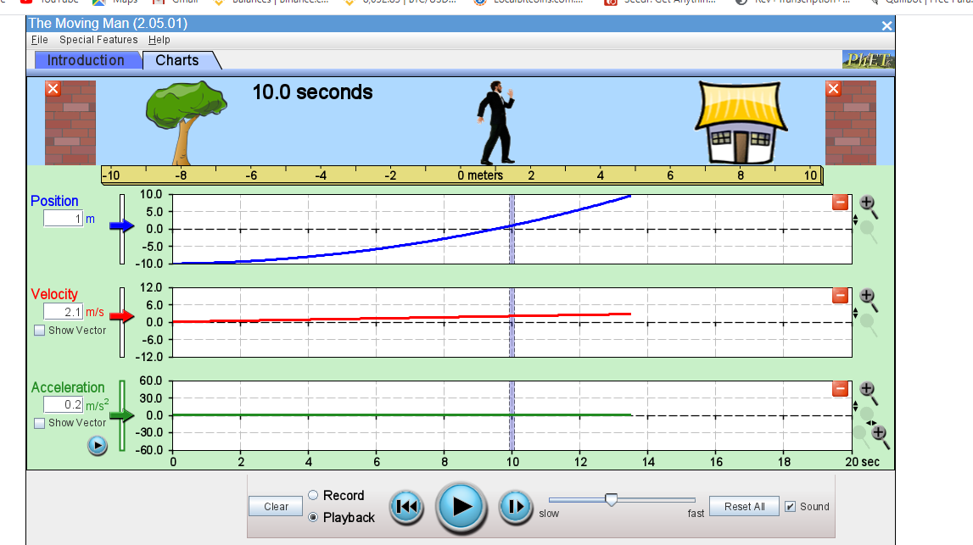
Step 11: Click the “Reset All” button. Type “-10” in the position box, “8” in the velocity box, and “-1.8” in the acceleration box. Click “Play” and observe the three graphs carefully as the man goes in the positive direction and returns back towards the negative direction. Pause the motion between the -8 and -10 meter marks on the way back, before the man hits the wall on the left end.
Use the playback feature to find time and position when the man stops during the motion.
t (man stops) = 4.4 sec
x (man stops) = 7.778m

Take a screenshot of your graph along with the position measurement when the man stops, and paste it below.

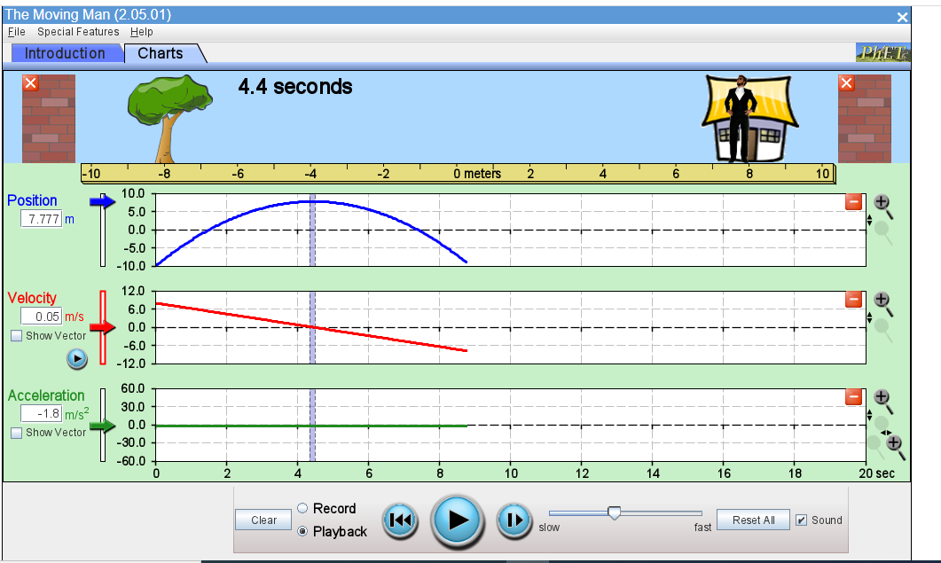

Also find the time and velocity when the man passes through the origin. If the man goes through the origin twice, write both values separated by a comma.
t (at x = 0) = 1.5sec, 7.4sec
v (at x = 0) =5.3m/s, -5.275
Step 12: Let’s make a prediction. Suppose that your car is at rest, so v_{i} = 0 m/s. You press the gas pedal and the car’s acceleration is constant at 1.5 m/s².
How long would it the car take to travel 25 m from the starting point? Show all your work below. (Remember you can use the three equations of motion of the last page as long as the acceleration is constant.)

25= 0t+1/2*1.5*t²
25=0.75t²
t²=25/0.75
t²=33.33
t=5.77sec

t (25 m) = 5.77sec
What is the car’s velocity when it reaches the 25 m mark? Show all your work below.

V=u+at
=0+(1.5*5.77)
=8.66m/s
v (25 m) = 8.66m/s
Step 13: Let’s test the prediction now. Go to the page:
https://www.walter-fendt.de/html5/phen/acceleration_en.htm
The initial position is set to 0 m, and the initial velocity is also set to 0 m/s. In the acceleration box, type 1.5 to set the acceleration equal to 1.5 m/s². Click on the “Start” button and observe the car speed up, when it passes the 50 m mark click the “Pause” button. The green box below the 25 m mark displays the time when the car reached the 25 m mark. Write this time below.
t (at 25 m) = 5.774sec

Take a screenshot of your graph along with the time measurement and paste it below.
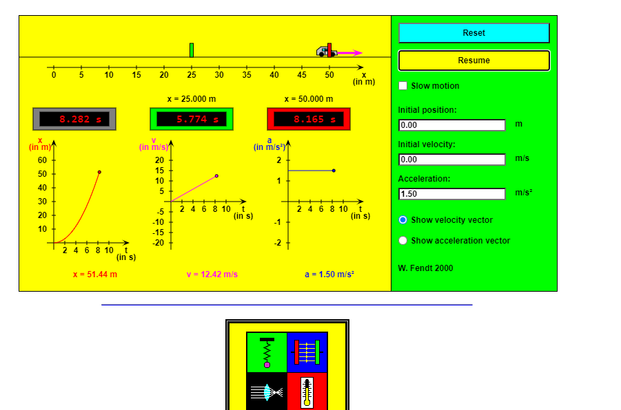

Was your prediction in step 12 correct?
Your answer: Yes
Step 14: Let’s make another prediction. Suppose that your car is initially at 30 m mark, moving with initial velocity v_{i} = 10 m/s. If a constant acceleration of -2.0 m/s2 is applied, what would be the car’s velocity when it reaches the 25 m mark? Show all your work below.
V²= u²+2as
V²=10²+(2*-2*5)
=80
V=sqrt 80
= 8.944m/s
v (25 m) = 8.944m/s
How long would it take to reach the 25 m mark? Show all your work below.

V=u+at
10.= 10+ -2t
2t= 1.056
t= 0.528sec
t (25 m) = 0.528sec

Step 15: Let’s test the prediction now. Go back to the page:
https://www.walter-fendt.de/html5/phen/acceleration_en.htm
Click on the “Reset” button and set the initial position to 30 m, initial velocity 10 m/s and the acceleration -2 m/s². Click on the “Start” button and observe the car slow down, it will stop and reverse its direction, when it passes the 25 m mark click the “Pause” button. The green box below the 25 m mark displays the time when the car reached the 25 m mark. Write this time below.
t (at 25 m) = 10.477sec
Take a screenshot of your graph along with the time measurement and paste it below.

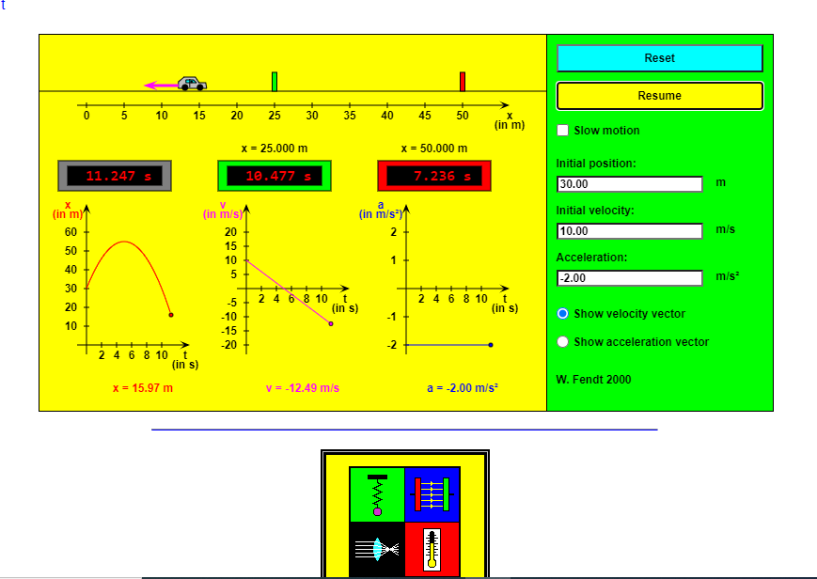

Was your prediction in step 14 correct?
Your answer: No

